Thinking like a Martian: Computer

It is big, rectangle shape. Normally in the colour black.
Has something called buttons that when pressed, it lights up like a portal.
It has these machines to cool it down inside. One the side of it has a see through window of some form where these components work together to produce what is known as a picture on a screen.
There is something called a mouse and keyboard that allows you to clicky away on the screen on these icons. One icon is called the internet, where you use the keyboard to input letters into a searchbar located in the top of the internet. It does other things like make a noise and changes the colour of the screen

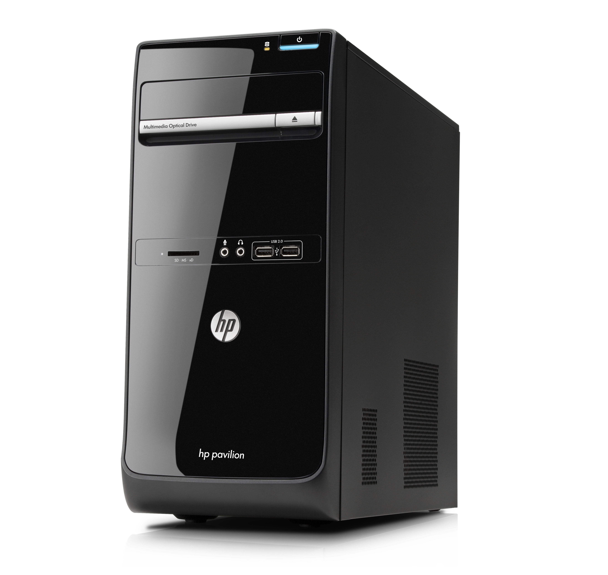

Task | Date | Start | End | Interruptions | Hours
Write out | 11/5/14 | 11.00 | 11.20 |  | 0.24
Proof Read | 11/5/14 | 11.20 | 11.30 |  | 0.08
Submit to source control | 11/5/14 | 11.30 | 11.40 |  | 0.08

